**APPRENTICESHIP COURSE WORK**

**BUSINESS SITUATION ANALYSIS**

**INTRODUCTION**

In the Hospital that is outdated, and inefficient and people are getting delayed, and Clinicians are getting increasingly frustrated with the current systems and their inability to manage the patient list and appointments effectively. The old system is clustered, and the response time is not fast enough. The sharing of patient details such as previous/ current treatments, and medications with other hospitals So, we need a new system replacement preferably electronic. The benefit of the new system is that it would bring more visibility to the various stakeholders (Consultants, Nurses, Junior Doctors, and clinicians) by making work easy and more streamlining patient information down to the most required and making it much more efficient to manage and help the staff to handle workloads and patient appointments effectively. This information, which is collected for all patients, can be used to provide better and more targeted healthcare for the individual, and collectively to provide the data needed to deliver care more efficiently and effectively to the population and to assist in the creation of new treatments and techniques. The new system will help the various stakeholders (consultants, Junior Doctors, Nurses, Matrons, Clinicians, and various clinical staff) to manage patient prescriptions, X-rays, Scans, and blood/urine test requests. The new system will also allow the hospital to introduce a virtual ward to help reduce hospital visits by making sure patients with critical medical issues/ emergencies are allowed or invited to attend the hospital.

Within the hospital currently, there are multiple systems and processes or touch points for all the departments across the trust and each has different processes of dealing with patients that come in for treatment and surgical procedures. Some may be electronic, or manual-based and very decentralised for example, all the systems a cluttered and not manageable which makes it very difficult for the trust and our regional partners to locate patient documentation/ notes very easily. So, the Trust needs a more centralized system and make everything fully automated for all the departments to be able to speak to each other and be aware of what is happening in terms of patient journey and treatment, and also the Trust wants to be able to oversee patient journey across all its local and regional partners and also to be able to communicate adequately and help give the patients the best care possible. The whole country was given a deadline of the 6th of April 2026 for the whole NHS to go digital so that patient care can be monitored and audited easily,

I will be using a series of tools and techniques (**SWOT** and **PESTLE)** to analyse the current business situation and make recommendations based on the tools and techniques. This will help improve the way patients are looked after and cared for when they come in for medical emergencies, coming in for surgical procedures, medical treatments, continuous rehab, and follow-up. Also, from medication prescribing to issuing.

**ANALYSIS OF THE CURRENT SITUATION:**

I conducted my analysis of the current situation by meeting with various stakeholders on various occasions by scheduling face-to-face meetings and they were very helpful all through the process from start to finish, by being willing to meet and discuss how the business situation analysis would help with clinical delivery within each ward. They contributed to the design and development of the new systems. The stakeholders/stockholders have supported me with all projects reviewing all the business modelling designs and making corrections and meetings to discuss the future state of the business models. I wouldn’t be able to finish my projects without input from stakeholders. They are the end users of the finished project so they must have a say in the design until the rollout, as our job is to make sure they are looked after and satisfied with the product.

I had to set up meetings with all the stakeholders/stockholders (Senior Nursing staff, Consultants, Clinicians, Medical directors, and Matrons) to discuss what is expected in the system. I ask questions about the changes that need to be carried out in the new system to address them by collecting all the information, and data that would help me build and design the target state (Future State) and then compare both information and note the changes that this would address while also identifying the gaps that would be addressed.

The stakeholders' engagement (Nursing staff, ward Managers and clinicians) was very instrumental to my being able to carry out the design of the process modelling. The wards and clinical staff would rely more on this new system to help them understand and treat their patient better. I had to go to the wards to observe how things were done and ask questions about what to expect from the new centralised system.

I had to conduct individual and group interviews with ward staff and stakeholders to try and understand what is expected in the new system. I visited wards to spend a day with the ward Nurses just so I could observe how things are done and how the new system would help consultants and clinicians manage their patients and workload effectively.

As part of my analysis, I will be addressing both external and internal analysis and its benefits and, in this case, I used a series of tools which are **SWOT, and PESTLE.**

I will now analyse the current situation using different tools and techniques (**SWOT, PESTLE)** to analyse the current practice and make some recommendations.

I then did a **SWOT** Analysis to determine the strengths, weaknesses, opportunities and Threats that the new business process modelling would pose. I know that most people fear change and enjoy staying with whatever they are used to, which is why the SWOT analysis would be looking at the fears and the opportunities that the new system would bring to the department. This is explained below: -

**SWOT, PESTLE, VMOST ADVANTAGES/ DISADVANTAGES:**

In the table below I will compare the advantages and disadvantages of using a SWOT Analysis to look at the internal factors that would affect the project negatively and positively.

|  |  |  |
| --- | --- | --- |
| **DEFINITION** | **ADVANTAGES** | **DISADVANTAGES** |
| **SWOT:** This is defined as the technique used for assessing four (4) aspects of business which are strengths, Weaknesses, opportunities and Threats (SWOT) This can help companies analyse what they do best and devise a successful strategy for the future. SWOT analysis helps to increase awareness of the factors that go into making a business decision or establishing a business strategy. | * This can serve as a valuable benchmark for tracking a company’s progress over time and businesses can monitor their performance and evaluate the effectiveness of their strategies to adjust as needed. These ongoing evaluations help ensure that organisations remain adaptable and responsive to changes in the industry. * SWOT analysis also allows leaders to benefit from the combination of quantitative and qualitative information. Having this data available can improve planning, increase communication, and ultimately lead to better decision-making. * **SWOT** can inspire innovation by highlighting areas where the company can improve or capitalise on emerging trends. By identifying gaps in the market or technological advancements, businesses can explore new ideas, develop innovative products and services, and stay ahead of the competition. * Involving employees in the **SWOT** analysis process can foster a sense of ownership and commitment to the organisation’s success. Employees who feel engaged and understand the company’s strategic direction are more likely to be motivated, productive and loyal resulting in a more comprehensive understanding of the company’s business position. * A Thorough **SWOT** analysis enables businesses to recognise opportunities in the market that they may have otherwise overlooked. These opportunities could range from untapped markets and new partnerships to technological advancements or shifts in consumer preferences. By identifying and capitalising on these opportunities, companies can increase their profitability. * This helps to identify potential threats and risks within the industry. These threats can emerge from various sources, such as competitors, changes in regulations, or economic downturns. By acknowledging these threats, companies can take proactive measures to mitigate their impact and safeguard their operations. * **SWOT** analysis can support effective risk management by identifying potential vulnerabilities and threats that could adversely impact the organisation. Effective risk management allows companies to better navigate uncertain market conditions, maintain operational stability, and ensure long-term sustainability. | * **SWOT** analysis is only one stage of business planning. Business planning requires several pieces of data, research, and analysis. Companies are likely going to need more than a **SWOT** analysis for adequate business planning. Companies are out to make appropriate and intelligent decisions for their business. Companies want to grow and be profitable and to achieve that, they will want as much information as possible. Unfortunately, SWOT analysis only concentrates on four (4) primary functions (Political, Economic, Social, Technological, (PEST). * Information overload can affect results. Most people sit down and brainstorm during the SWOT analysis. No information is too small to be added. SWOT analysis doesn’t the company where to focus attention or effort, and it doesn’t have a threshold for information. You will never know if the information gathered is too much or too little. Although that can be a problem, the issue lies elsewhere. Especially, you may have too much information for a section that doesn’t matter as much as another. * **SWOT** analysis becomes an impossible subject without the right information. All strategic business decisions should be based on reliable and relevant information. In most cases, this means using facts and data from reputable sources. SWOT analysis typically goes against the format. Unlike other formal analyses. SWOT doesn’t require scholarly information to be successful. * A lack of hierarchy leads to problems. SWOT only represents four (4) study categories: Strength, Weakness, Opportunity, and Threats. These four categories are the only points included in the analysis. If it doesn’t fit into one of these four (4), it would be shoved to one side. So, the problem lies in the lack of hierarchy. Which one needs it at least? Only the company can decide because SWOT doesn’t say. Any wrong decision can jeopardise the company’s success in the future. * One disadvantage is that SWOT analysis may be a listing technique that helps the company group how different factors affect the business. It may be challenging to determine the significance of each factor versus others on a different list. For instance, the company lists the availability of financial resources as a strength and the lack of a suitable business location as a weakness. The SWOT analysis may simply categorise both factors as a strength or weaknesses when, ideally, the availability of capital is a good enough strength to overpower the effects of lacking a business location. |
| **PESTLE:** This is a concept in marketing principles. However, this concept can be used as a tool by companies to track the environment they operate in or are planning to launch a new project, product, service etc. **PESTLE** can also be referred to as PEST and is a mnemonic which, in its expanded form denotes (**P-Political, E-Economic, S-Social, T-Technological, L-Legal, and E-Environmental**) which gives a bird’s eye view of the whole environment from many different angles that one wants to check and keep track of while contemplating ideas or plans. | * **Cost Effectiveness:** The only cost of PESTLE analysis is time. While additional programs can help organise input and feedback, PESTLE analysis can be completed through a simple document or pen and paper. PESTLE analysis is also straightforward. The amount of research necessary, how much time, and how often you do PESTLE analysis for your firm is optional. * **Deeper Understanding:** Without PESTLE analysis, environments that directly or indirectly affect business can go unnoticed. For example, you may overlook safety and consumer laws when developing the prototype of a product. Or you may not realise which technological barriers customers in rural areas face, compared to customers in highly populated areas. If your product works well in its current environment, exporting to the other side of the country may be financial suicide. Or disaster. * **Alertness Development:** While we can use PESTLE to Analyse firms in a broad sense, it can also be narrowed down and used for specific products, marking plans, and customer relationships. Particularly, when used in development within the firm, PESTLE analysis can raise awareness of potential threats. Whether that is an existing competitor, an upcoming competitor or within your own products. * **Exploit Opportunities:** Opportunities are often external. By using PESTLE analysis to study external environments, opportunities can be found and used to strengthen a firm’s business model. If you are using PESTLE analysis to research social and technological trends, for example, you could learn that your target market is moving towards a new social media channel. This is now an opportunity to build and create a marketing campaign before your competitor. A strong outreach approach allows converting these users into customers before anyone else. | * **DATA ISSUES:** (a) data quality issues due to multiple data models; (b) data not in real-time and less reliable due to multiple versions of the truth; (c) data ownership unclear due to multiple data versions and handlers; and * **FUNCTIONALITY/EASE OF USE AND COST ISSUES:** (a) lack of integrated functionality resulting in users having to navigate multiple legacy systems to take actions (order tests, prescribe drugs, schedule appointments/MDTs, communicate with multiple agencies, document care, use decision support, drill down into past data, plot real-time vitals); (b) need for multiple IT skills and support teams; (c) multiple suppliers, contracts, upgrades; (d) potentially higher costs over time. These issues are not resolved by open interoperability standards or FHIR. The authors are preparing a separate paper addressing these factors. These challenges will apply equally to the IT strategies considered for an Integrated Care System such as the Shared Care Record. Shared Care Records are extracts from other information systems to facilitate read-only information access by staff in other facilities. They are based on interfacing systems from different vendors and so share the same problems as those that attend best-of-breed EPRs. * **Lost of Data:** Most data isn’t easily found. Unfortunately, a lot of the data you’re after isn’t easily obtained online. If you find anything, it will likely be cloaked in a vacuum of information. It could take hours to sift through and you won’t know if it’s trustworthy. We’re in an “information overload” age. Anyone with a computer, phone or tablet can write whatever they want and publish it. And most time those articles can bog down your search. |
| **VMOST:** This can also be referred to as **MOST Analysis, which** is a framework and evaluation technique for strategic planning in an organisation. This type of analysis ensures stakeholders in an organisation gain reliable insight into the desired changes in their organisation. After carefully performing this analysis, it will present various options on how to bring about change while keeping sight of the strategic and long-term vision of the organisation. | * It Helps define what the organisation has set out to achieve (the mission and objectives). * Determines how it aims to achieve this (strategy and tactics). * Identifies, strengths, weaknesses, opportunities, and threats that the organisation faces. * Helps the organisation communicate its purpose. * Helps define business and transformation roadmaps to help enable the strategy. * Enables alignment with stakeholders. * Avoids day-to-day distractions and provides a basis for overall strategic direction. | * The MOST model can be difficult to implement in practice as it requires a high level of buy-in from multiple parties within the business (and often external stakeholders). * MOST has been criticised as it can be difficult to measure the success of an organisation against its mission and objectives. * MOST require a high level of commitment and effort to be successful. * MOST analysis should not just involve senior management but also require support from across the entire organisation, including other stakeholders such as customers and suppliers. * MOST analysis can be a tricky technique to use when assessing internal capability. It is important to remember that merely defining and displaying a coherent MOST does not necessarily result in buy-in and motivation on the part of the staff. |

**PESTLE AND SWOT BASED ON THE CURRENT SYSTEM**

|  |  |
| --- | --- |
| **PESTLE:** | |
| **Political:**   1. Changing government impact on NHS. 2. Changing Health Ministers. 3. Better care fund initiatives with Local Authority. 4. Funding, grants and initiatives. 5. Home market lobbying groups 6. Political trends. 7. Terrorism. | **Economic:**   1. Financial position to develop technical solutions. 2. NHS England's financial potential in the future. 3. Balanced financially with neighbouring trusts. 4. Financial monitoring from Monitor. 5. Third-party price rises. 6. Digital workforce Gap 32,000 by 2030. 7. Sector-specific taxation changes. 8. Tariffs. 9. Job growth /unemployment. |
| **Social:**   1. Effective links with other NHS, local and national organisations. 2. Engagement with local authorities’ health and social care 3. Social media use internally and externally – trust reputation. 4. Patient Digital capability. 5. Below national and regional average hourly pay. 6. Immigration/emigration. 7. Living standards Service-user need pattern. 8. Ethnic/ religious factors. 9. Demographics. 10. Population shifts. | **Technological:**   1. Experts within the health informatics environment. 2. discoveries. 3. Better use of Biotechnology 4. Ability to redesign technical aspects in order to provide effective solutions. 5. Vast NHS Experience within technical procurement for solutions. 6. Health informatics national benchmarks are carried out regularly. 7. Health informatic audited within agreed areas on an annual basis. 8. Rate of technical change. 9. Development in Robotic Automation. |
| **Legal:**   1. Qualified professionals with experience in various legislative areas. 2. Trust appointed legal specialists for advice. 3. Experience and maturity regarding contractual developments. 4. Third-party confidential agreements in place. 5. Data processing agreements in place. 6. GDPR. 7. Data Security and Protection Act. | **Environmental:**   1. Trust lies within a large geographical area, managing resources and patients to the best provider. 2. Three PFI hospitals and developing other sites potential to expand ED footprints and theatres. 3. Compliance with equality and diversity. 4. Net Carbon Neutral. 5. Waste from Electrical and Electronic Equipment regulations. 6. Cooling data centres as outside temperature rises. 7. Staff engagement. |
| **SWOT:** | |
| **Strength:**   1. Talented leaders dedicated to success. 2. Strong experience in Electronic Patient Records demonstrating. 3. Consistency of inputs and perspectives. 4. Very Knowledgeable and experienced team across health and care. 5. Local autonomy. 6. Management understanding of the challenges and the opportunity. | **Weakness:**   1. Multiple Systems. 2. Multiple Data entry record duplication. 3. Separate Logins for each system across settings. 4. Mobile working & devices not supported. 5. Certain systems are used for extended purposes (RiO mental health system used for Adult Care). 6. Little or no business intelligence from the legacy systems. 7. Lack of a strategic approach to replacing or extending systems & poor contract management. 8. Clinical coding process which is more time consuming. 9. User competence/training. 10. Legacy IT (Infrastructure/ Devices / Software versions). |
| **Opportunities:**   1. When offered the chance to supply to an integrated healthcare organisation, suppliers can react favourably. 2. Gaining knowledge from other nations, such as Northern Ireland. 3. Possibility of serving as a model study for other ICSs 4. A chance to take a provocative stance. 5. Feedback indicates that suppliers are amenable to cost sharing. 6. Creating this solution might present a chance to deal with current data-sharing problems. 7. Involve clinicians early in the process. 8. Create shared priorities and an agreement for the future course of action. | **Threats:**   1. Out-of-support legacy systems 2. Reluctance to share information across organisation and national boundaries (data sharing agreements). 3. Some systems are nearing their "end of life," such as Medway and EMIS. 4. Clinical risks persist if patient record history is not fully obtained. 5. The level of culture changes necessary. 6. External events or pressures impact timescales due to the attention required and the ability of stakeholders to deliver the change under such circumstances. 7. The cost of the preferred option and ongoing costs may be high. |

**TECHNOLOGY AND INDUSTRY TRENDS:**

Within the healthcare sector, there has been a big move towards more centralised Electronic Patient Records (EPR) systems. I researched online to understand the industry's best players and found that CERNER and EPIC are the two main suppliers in the UK. But there are 11 in total that are known in the UK healthcare sector. The trend in electronic patient records (EPRs) deployment in the United Kingdom and the United States hospitals, where Electronic Patient records (EPRs) are used across the healthcare setting, has potentially significant implications for Integrated Case Systems (ICSs).

Analysis of the Electronic Patient Record (EPR) system used by each of the 146 acute hospitals in England (as of July 2020) shows that 54 hospitals which make up (37%) use the best of breed, 82(56%) use integrated EPR solutions and 10(7%) use in-house EPRs, as shown in the diagram below.

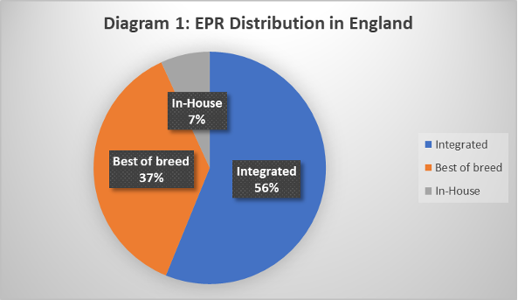

**(David Kwo, 2020)**

The diagram below shows the trend in best-of-breed and integrated EPR types (excluding in-house) in hospitals in England from 2000 to 2020 (the uptick in 2003 is due to the National Programme in IT).

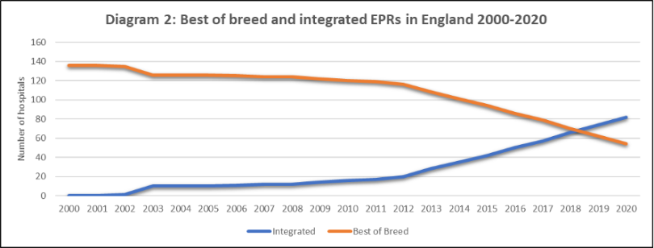

**(David Kwo, 2020)**

The Electronic Patient Records (EPR) suppliers in the UK as of July 2020 and the number of contracts signed in the UK (as reported in the health IT media). This is shown in the diagram below –

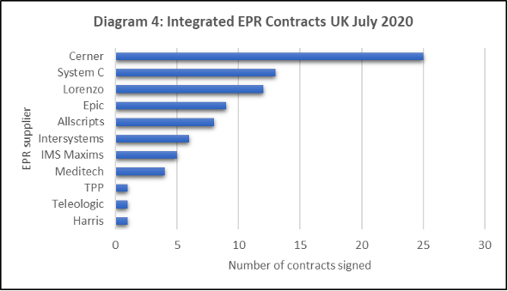

**(David Kwo, 2020)**

In the table below I have listed the hospitals in the UK that use or plan to use a single integrated electronic Patient Record (EPR) system across multiple hospitals and care settings: -

|  |  |
| --- | --- |
| **WHO SHARE A SINGLE INTEGRATED EPR ACROSS HOSPITALS?** | **WHO SHARE A SINGLE INTEGRATED EPR ACROSS CARE SETTINGS?** |
| * Imperial College Healthcare and Chelsea & Westminster Hospital (Cerner, separate Trust, in live use). | * **Royal Devon and Exeter** (in live use across acute and community care settings). |
| * **University College London Hospital** (covers 8 hospitals) (Epic, same Trust, in use) | * **Guy’s and St Thomas’, Royal Brompton, King’s College Hospital** (planned use across acute and community care settings). |
| * **Bradford Teaching Hospitals and Calderdale and Huddersfield**(Cerner, different Trusts, in live use) | * **Northern Ireland** (planned use across all 5 acute hospitals, community and social care). |
| * **Manchester Foundation Trust** (covers 9 hospitals) (Epic, same Trust, planned). | * **Devon STP** (there is a plan to use a single integrated EPR system across acute, community and social care organisations, subject to approval and funding). |
| * **Royal Devon and Exeter and North Devon Healthcare**(Epic, different Trusts, pending approval). |  |
| * **Guy’s and St Thomas’, Royal Brompton and Harefield and King’s College Hospital** (Epic, different Trusts, |  |
| * **Northern Ireland** (Epic, 5 separate acute hospitals, planned |  |

**(David Kwo, 2020)**

This trend suggests that UK hospitals believe that a strategy for sharing a single integrated Electronic Patient Records (EPRs) can reduce cost and reduce unwarranted variation and ultimately improve the quality and safety of care for patients.

**THE PRINCIPLES/ DIFFERENCES OF WATERFALL AND AGILE METHODOLOGY**

Traditionally waterfall approaches tend to treat scope as a driver and calculate the consequential time and cost; whereas agile commits to set resources over limited period to deliver products that are developed over successive cycles.

**Agile** and **waterfall** approaches to project management exist on a continuum of techniques that should be adopted as appropriate to the goals of the project and the organisational culture of the delivery environment.

Overall, agile and waterfall approaches to project management both bring strengths and weaknesses to project delivery, and professionals need to adopt a “golf bag” approach to selecting the right techniques that best suit the project, the project environment and contracting parties with an emphasis on the behaviours, leadership and governance, rather than methods, that create the best opportunities for successful project delivery.

1. **DEFINITION OF AGILE:** Agile development, or agile project management, is an iterative and incremental method of managing the design and build activities for engineering, information technology, and new products or services development projects, for example, agile software development. It requires capable individuals from the relevant business, with supplier and customer input to work in a highly collaborative manner, in small stages, to complete small portions of the deliverables in each delivery cycle(iteration), and where possible deploying deliverables to live(increment) to achieve value and real feedback, whilst iterative methods evolve the entire set of deliverables over time, completing them near the end of the project.

The result is a product that best meets current customer needs and is delivered with minimal cost, waste, and time, as the iterations encourage feedback and review, achieving benefits earlier than via traditional approaches.

**AGILE SOFTWARE DEVELOPMENT LIFE CYCLE**

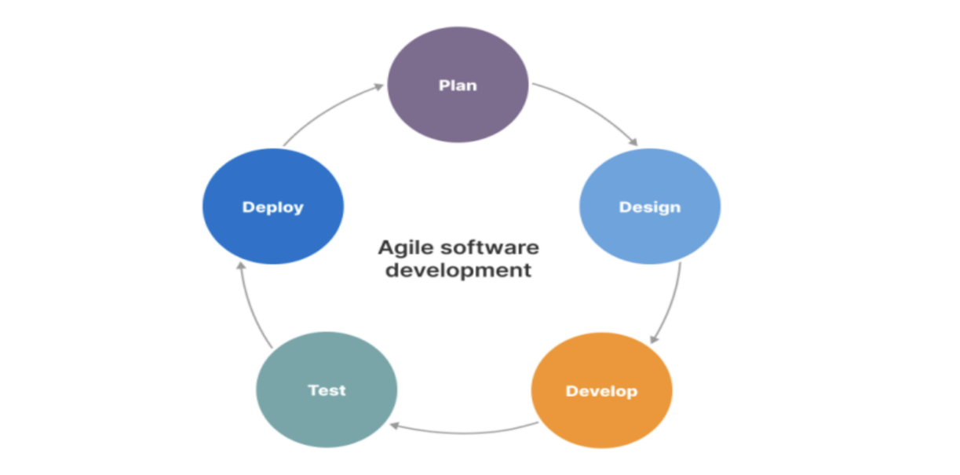

**(Shafiq, 2023)**

**PROS AND CONS OF PRACTICAL ADOPTION OF AGILE METHODOLOGIES:**

|  |  |
| --- | --- |
| **WATERFALL:** | |
| **PROS** | **CONS** |
| * Works best when there are defined requirements. * Best for a stable environment * The team is distributed and hence control can be managed by defined deliverables, milestones, and dependencies. * Best if scarce skills or resources have limited availability. * Plans are repeatable for similar projects. | * Requires investment to define scope and schedule before work begins. * Scope changes can be slow and the adverse impact increases over the life cycle. * Risk of nothing to show for the money until the end. * Change adds effort and risk, so a strict change control process must be in place to avoid ‘scope creep’. |
| **AGILE:** | |
| **PROS** | **CONS** |
| * Works well when the detailed requirements are unknown or subject to change. * Give flexibility to ‘course correct’. * Needs regular stakeholder feedback. * The team is co-located, multi-functional and enables to work collaboratively. * Early return on investment by regular delivery. | * No advantage for projects where the scope and detailed requirements are well understood, and change can be controlled. * Uncertainty around scope and schedules can make stakeholders nervous. * Less effective if the ‘team’ is distributed. * Demands management and prioritisation of the backlog. |

**(Association for Project Management, 2024)**

Agile software development is a project management approach that values flexibility, collaboration, and constant adaptation to change. The Agile methodology was first introduced in 2001 with the publication of the Agile Manifesto, which outlined the principles of Agile software development.

The key principles of Agile software development include the following:

* Individuals and interactions over processes and tolls.
* Working software over comprehensive documentation.
* Customer collaboration over contract negotiation.
* Responding to change over following a plan.

Agile software development focuses on delivering working software in small, incremental iterations, known as sprints. This allows teams to quickly adapt to changing requirements and feedback from stakeholders, and to deliver high-quality software that meets the needs of the customer and the company.

The Agile methodology also emphasises close collaboration between development teams, stakeholders, and customers, with regular meetings, such as daily stand-ups and sprint retrospectives, to ensure that everyone is aligned and informed.

Agile software development is often used in combination with scrum, and agile framework that provides a set of best practices for managing software development projects.

**DEFINITION OF WATERFALL:** The waterfall methodology involves breaking down each part of a project into clearly defined sequential phases. The word “waterfall” illustrates the way the water flows in one direction down a waterfall, as you can only complete each project stage in order - backtracking is allowed.

Imagine a series of pools separated by waterfalls. These pools represent each stage in the project management timeline, from planning to development to release. The water cannot reach the next pool until it is full and overflows into the next. Likewise, using the waterfall method, you only move on to the next stage when the current stage is 100% complete.

**WATERFALLS METHODOLOGY**

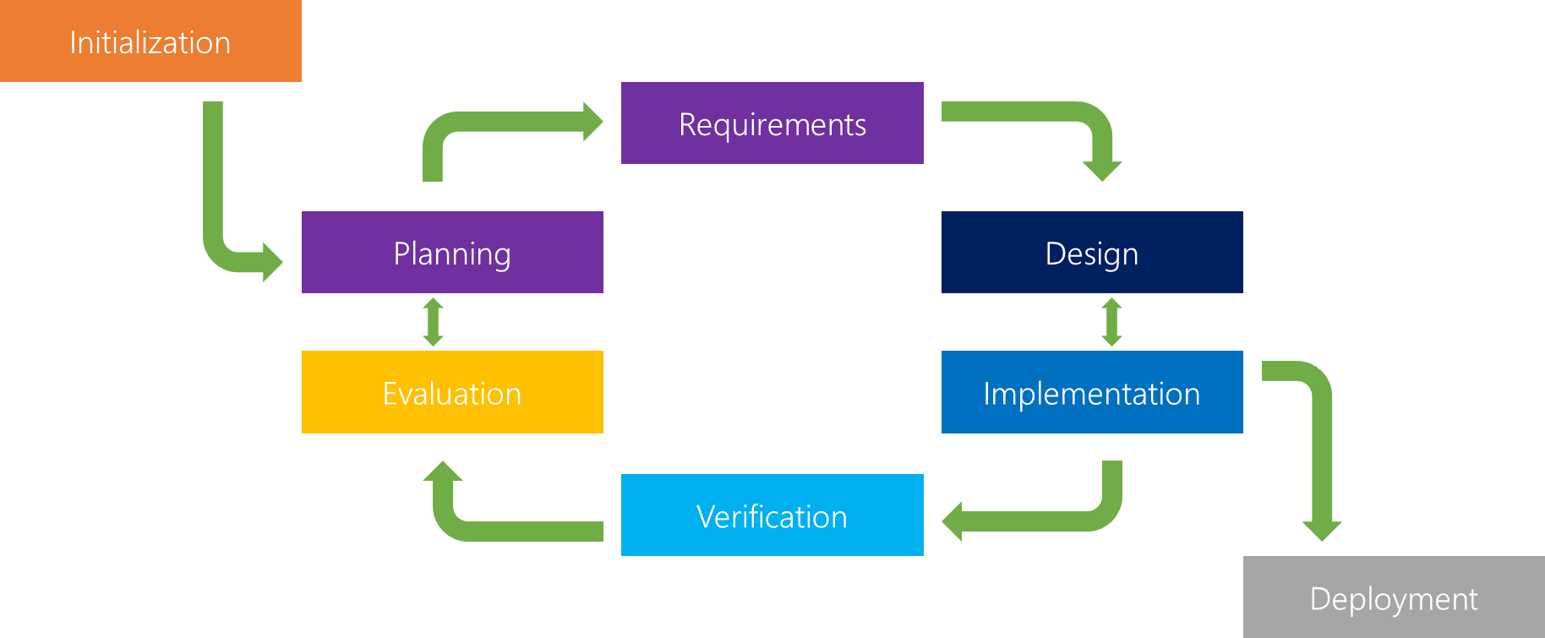

**(THINKTHYME, 2024)**

The waterfall methodology consists of six (6) phases which are detailed below:

* **Requirement Gathering and documentation:** This is the most crucial phase of the project and is likely to be where success and failure are set in stone. This is mostly research and the building of a clear business case. It is also about project design, making sure all people involved in the project know their roles. A good strategy is to create what is sometimes referred to as swimming lanes.

This is a flow diagram of tasks and outcomes divided amongst team members and laid out along a timeline. It is also something that can be devised on a chart, with dependencies set. This way individuals viewing this overview of the work to be done can see how they fit in with the work of others and how any slipping of time can adversely impact the flow of work.

* **System Design:** As with most project management strategies, the waterfall has firm roots in software production. It is where no coding takes place but instead, specs are established for how the work should be completed. It is easy to see how this extrapolates out to other sectors.

In construction, for instance, this would be the part of the process where the architect draws out the plans, the electrician might design the lighting model, the plumber the water model and the builder a design the work cards for different crews.

* **Implementation:** This is where the product gets produced. Waterfall project management tends to work best where there is a concrete outcome that must be created over a set period. Everything in this phase should already be designed, planned, and thoroughly documented in Phase 2. (System Design).

There should be no need to stop to reflect because everything is set in stone in the system design. Individual workflows will be reliant on the whole team doing what is specified.

* **Testing:** If there are failures at this point, then there is no other choice than to go back to phase 1(requirement gathering and documentation) and redesign the whole project. This is the biggest failure of this methodology and why subsequent project management methodologies tend to emphasise iterative processes, which reflect and adapt the work based on a short burst of work followed by testing.

This way the project stays on track and potential failures are spotted before a point, such as this, where a failure means starting all over again. However, what you are guaranteed with the waterfall methodology is that there will be no drift from the initial brief and requirements. It is a simple matter of saying we want Z and we are going through steps A-Y to achieve it.

* **Delivery:** Here the work is complete and submitted to the clients, deployed, or released to the customer.
* **Maintenance:** In software terms, this phase is all about creating the patches and updates that overcome any problems in the coding. In the construction industry, it would be remedying the snag list created by the customer. If there is a significant issue at this stage, it is possible for the project to revert to stage 1 again and the whole thing starts over.

There are three (3) basic principles to the waterfall methodology:

* **Strict, one-way structure:** When using the waterfall method, you split your project into discrete stages that allow you to complete each stage in order. There is no going back or changing course if something unexpected happens. Instead, if something goes wrong, you must start at stage one again.
* **Little to no stakeholder involvement after the first stage:** Due to the structure of the waterfall methodology, you must document all stakeholder interactions in the first stage. After this, due to the strict structure of the waterfall model, there is no way to implement changes and stakeholder communication ceases.
* **In-depth upfront documentation of the entire process:** To solve some of the limitations of the waterfall method, documenting each stage in detail upfront is critical. As you won't be able to receive feedback from clients throughout the process, you need to make sure to document all essential requirements before starting the project.

The waterfall approach has been popular in the construction industry where there needs to be strict order to activities. In construction, once a stage has been completed, it is often irreversible. For example, there is no way to “unpour” concrete. Similarly, you cannot begin laying bricks until the concrete foundation is down.

However, it has since been adapted more generally to project management. It’s especially well-known for its use in software development to create products such as customer relationship managers (CRM) and similar project management tools.

**HOW DOES THIS RELATE TO THE EPR PROJECT IN MY NHS TRUST:**

Electronic Patient Records (EPR) have become a major part of healthcare IT today. The approach to EPRs is likely the biggest technology decision my trust (University Hospitals Plymouth NHS Trust) has taken, and it has been in the planning stages for the past 6 years. It’s a huge investment that comes with consequences that will last for decades and going live is just a start. Some of the aims of electronic Patient Records (EPR) within my NHS Trust would include the following:

**AIMS AND OBJECTIVES OF EPR INTRODUCTION TO MY NHS TRUST**

* The reduction in the number of times you need to log into different IT systems.
* Provide safer care and treatments for patients because patient notes will always be available to clinicians, consultants, nurses, and other healthcare professionals electronically.
* This will reduce the reliance on paper processes and the risk of lost or misplaced patient notes, and documents.
* Support for more collaborative and flexible ways of working.
* Make information available for clinical decision decision-making, quality improvement and research purposes.
* Improve operational performance and put our patients and service users at the centre of our care.

University Hospitals Plymouth NHS Trust have over one hundred (100) clinical IT systems which consist of 30 core clinical systems and a further 70 other bespoke systems and they don’t integrate well with each other or with our regional and local partners which makes us heavily reliant on paper notes. It is very difficult to share information, deliver integrated care, or transform care. Our IT infrastructure is ageing and needs constant investment and improvement to help maintain it. The digital knowledge of our clinical and operational staff is evolving and increasing, and we need to match this with the systems that we use as a Trust to enable the very best ways of working and better decision-making. The EPR IT system is co-designed by clinical staff which includes Doctors, Nurses, Midwives, Pharmacists, and allied health professionals to make sure it meets the needs of those who will use it. And bring real benefits to their patients in preparation for the new Electronic Patient Record (EPR) I was designated to design a business process model that captures patients' entire journey from point of admission to discharge in preparation for when the procurement team would be going out in search of the right product. I will be presenting my design to various stakeholders on the 29th of January 2024, and this will be for them to make any vital observations and amendments if any before I hand it over to the procurement team.

**ELECTRONICS PATIENT RECORDS(EPR) FRAMEWORK**

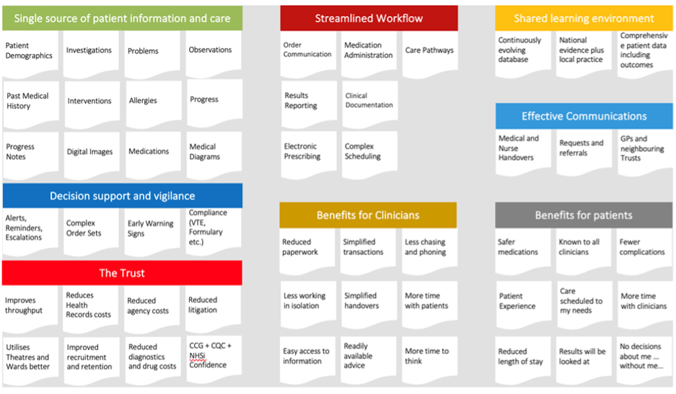

**(Best Practice Group PLC, 2021)**

**KEY FINDINGS AND RECOMMENDATIONS:**

We are recommending Electronic Patient Records (EPR) to help manage patient information and care, streamline workflow, decision support and vigilance. The likelihood is following the pathways that the healthcare industry is going and the other Trusts across the country, that we are recommending a similar system to be put in place like Electronic Patient Records (EPR).

I will discuss the introduction **of Electronic Patient Records (EPR)** which would be rolled out within my NHS trust and how this would help improve service delivery within the Trust.

**WHAT IS EPR?**

This is an **Electronic Patient Record (EPR)** which is a digitised version of an individual’s paper medical record, alongside a whole host of other information about the patient (immunisation status, lab test results, personal statistics, billing information (which in this is used for international patients that are not residence in UK to be qualified for free healthcare), allergies and suchlike. The benefit to the patient means they can attend any hospital as their full health record will be available for doctors to access, including medication, consultation history, scan images, etc.  Having a full record for healthcare professionals minimises the risk of something important being overlooked and compromising the care provided.

This information, which is collected for all patients, can be used to provide better and more targeted healthcare for the individual, and collectively to provide the data needed to deliver care more efficiently and effectively to the population and to assist in the creation of new treatments and techniques.

The collective digitised health records are securely stored in an **Electronic Patient Record (EPR)** system allowing for improved workflow efficiency, safety checks, prompts and so forth. The EPR system can also be linked to other NHS systems (e.g., Drug prescribing system, GP systems in the community (GP Connect), community health systems) and hospitals.

**BENEFITS OF SHARED SYSTEM ACROSS THE TRUST AND THE COMMUNITY AND POTENTIAL SERVICE IMPROVEMENTS:**

* The benefit of the **Electronics Patient Record (EPR)** will help University Hospitals Plymouth NHS Trust to cover a lot of miles across Devon and Cornwall and Patients would be able to visit more hospitals with ease this would include community hospitals or community specialist care centres. The EPR will also minimise data repetition by staff members across hospitals in the region.
* **The Electronic Patient Record (EPR)** will help mitigate the rurality of the local area through enhanced clinical sharing and virtual clinical input i.e., shared patient records mean that somebody who lives in a rural area and doesn’t have the means to attend appointments in the hospital can have a medical/medication review with a consultant remotely, saving them the time to make long journeys. This can also improve patient experience with our services.
* This will also give the trust the ability to manage patient information across all platforms and make sure up-to-date patient information is available on all devices across several locations in the Devon and Cornwall area.
* The benefit to patient safety and faster treatment outcomes with the sharing of knowledge and insights across all sites and the opportunities to share IT services which minimises the purchase of more EPRs by other NHS Trusts across the region.
* This will enhance individual experiences for patients by removing the need to always provide personal information to healthcare professionals each time they have appointments and this
* also poses the risk of patients or staff members forgetting vital information each time the patient attends appointments.
* **The Electronic patient record (EPR)** will increase productivity and eliminate the need for unnecessary repetitive tests while enhancing the safety of patients by making comprehensive and trustworthy allergies, medications, diagnostic and social context information available in all healthcare settings, i.e., Accident and emergency (A&E) and when an ambulance is summoned or called.
* This will provide individual access to shared healthcare records and promote citizens' engagement in their own treatment and adherence to medication and care plans.
* Help enhance healthcare professionals’ comprehension of a patient's condition and allow clinicians to create a tailored treatment plan if necessary.
* These will help reduce unnecessary hospital admissions and encourage more appropriate hospital admissions by providing healthcare workers with more information about the patient when making clinical decisions. And eliminate manual information requests.

**HOW I COMMUNICATED THIS TO VARIOUS STAKEHOLDERS:**

I communicated this to various stakeholders by meeting with each stakeholder to discuss their expectations from the new EPR and make sure they were carried along throughout the process of business process modelling which I designed using Microsoft Viso and after the design phase went back and forth to make sure that the stakeholders were happy and satisfied with the progress I made throughout the design. I was meant to present the final project design to the various stakeholders on the 22nd of December 2023, but this was moved to the 29th of January 2024. I know that I can never get it 100% correct in terms of the design, which is expected. And outlining the various benefits of Electronic Patient Records (EPR) to the Trust and how this will help them deliver good patient care to their patients across the Trust and its regional partners.

I sent the business process model to the procurement and project implementation teams ahead of the meeting for them to look at the design and come up with any changes and for them to include anything I have missed in the design process. We had a meeting over Microsoft Teams on the 19th of January 2024 at 2:30 pm to try and see what needed to be added before the presentation to the stakeholders on the 29th of January 2024. Below is the screenshot from the meeting.

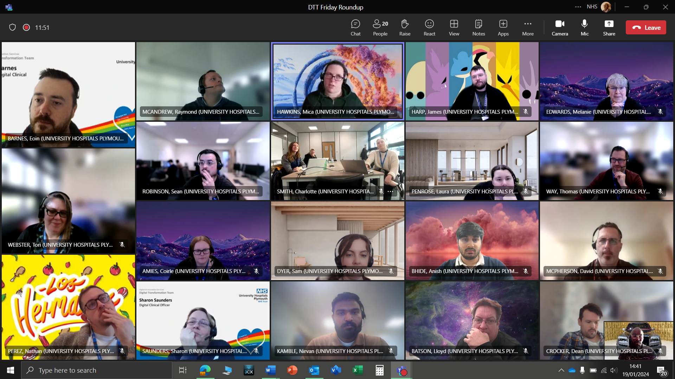

**Electronic Patients Record (EPR) Project Implementation Meeting 19th January 2024**

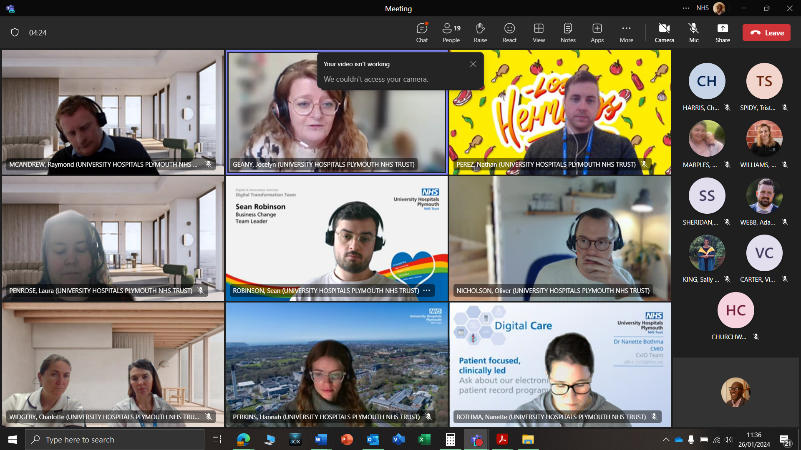

**Electronic Patients Record (EPR) Stakeholders Engagement Meeting 26th January 2024**

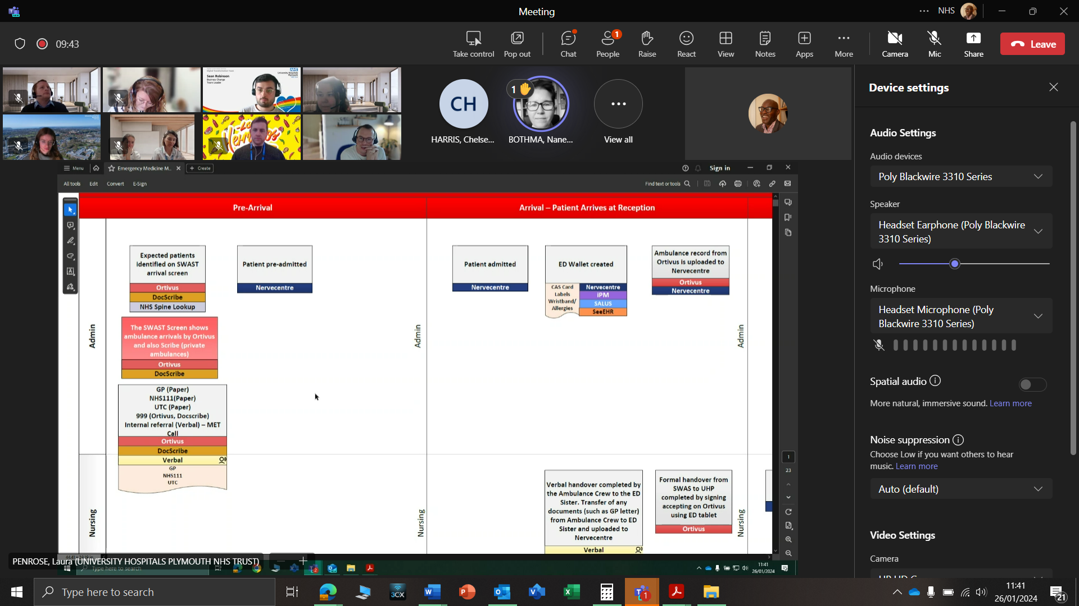

**Electronic Patients Record (EPR) Baseline Mapping Stakeholders Engagement Meeting 26th January 2024**

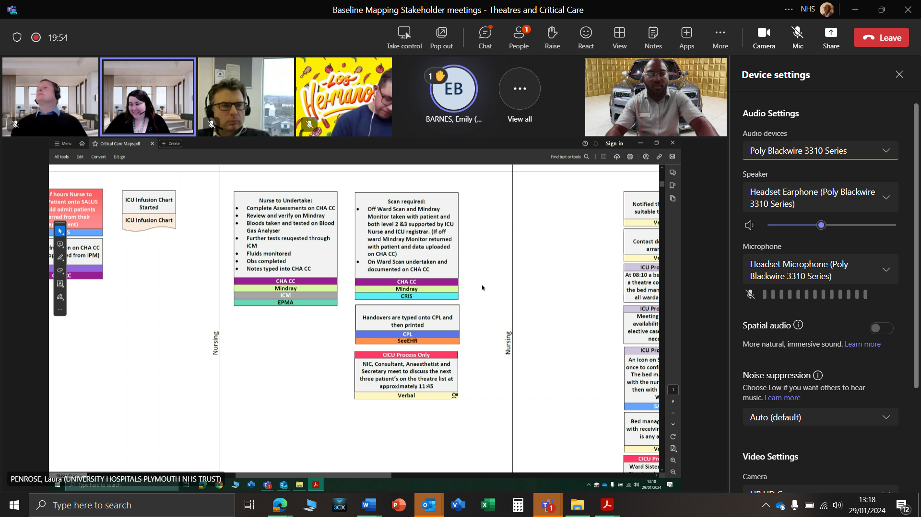

**Electronic Patients Record (EPR) Theatre Baseline Mapping Stakeholders Engagement Meeting 29th January 2024**

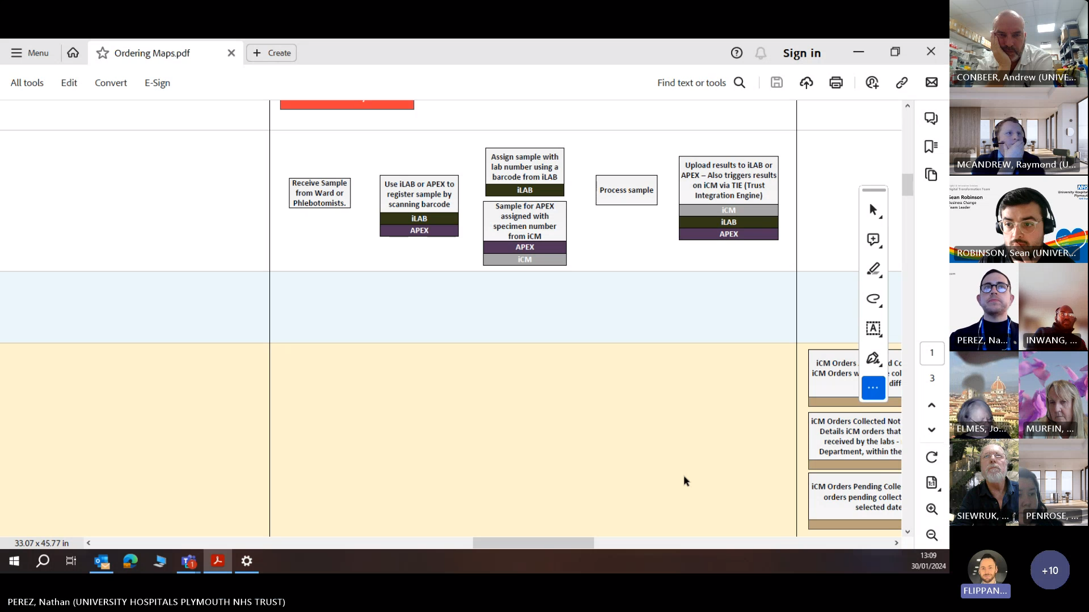

**Electronic Patients Record (EPR) Theatre Baseline Mapping Stakeholders Engagement Meeting 30th January 2024**

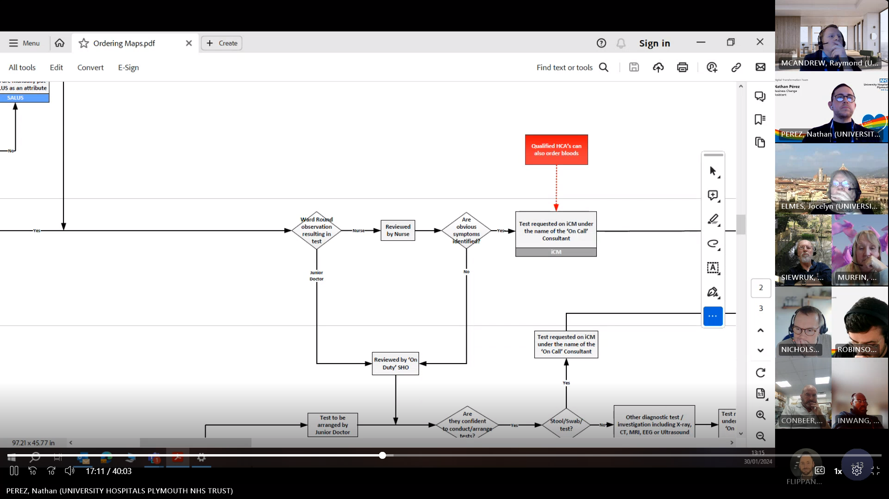

**Electronic Patients Record (EPR) Theatre Baseline Mapping Stakeholders Engagement Meeting 30th January 2024**

**ELECTRONIC PATIENT RECORDS (EPR) BASELINE MAPPING STAKEHOLDERS’ ENGAGEMENT:**

The stakeholder engagement baseline map presentation was a great opportunity for the stakeholders to review and understand the process modelling that captured all the Theatre processes of a patient's journey from the point of admission, treatment, and to the point of discharge. As my screenshots explain in the pages above. The stakeholders were engaging with their questions about the process modelling and also filled the gaps that I missed while designing the process. I know getting it right the first time was never going to be easy, and the stakeholders confirmed that in their viewpoint.

The stakeholder’s engagement regarding the pharmacy medication prescribing process was well received by the stakeholders and they contributed to some minor changes that were not picked up at the time the process modelling was put together by the Business Change Team (BCT). The stakeholders offered to meet with me on an individual basis to go through the process maps so that corrections can be made in the areas that we have not addressed properly during the time of design.

**EPR -BENEFITS TO MY NHS TRUST**

|  |  |
| --- | --- |
| **Clinicians**  Clinicians will have more information at their fingertips to make better, more effective decisions. You’ll have automatic access to decision support tools, meaning your decisions will be made based on the best available information. An EPR will:   * make you more efficient. * create a smoother care journey for your patients. * enhance communication across clinicians and teams. * reduce duplication and reduce some of the data collection burdens from people by capturing some things automatically. * enable you to monitor patient outcomes much more effectively and build upon what works for patients. ​​​​​​​ | **Administration Staff**  Requesting paper notes will reduce significantly as the patient record will be accessed digitally so administrators will have immediate access to the record.  It will make several administrative tasks easier to manage as information will flow around the organisation more easily.  The types of administrative tasks that will be different with an EPR are:​​​​​​​   * Patient appointments will be sent digitally, not by letter. * Requesting paper notes will slowly stop as the patient record will be accessed digitally so administrators will have immediate access to the record. * Access to the full patient record can be from anywhere.   Fewer paper-based processes such as paper form filling/processing |
| **Patient Perspective:**  It will improve the patient experience in the Trust. They will only have to tell their story once - rather than being asked for the same information at every point in their care journey. They will be safer - the Electronic Patient Record will flag up things like allergies and past interventions. These changes will also allow patients to engage with their care much better and strengthen the partnership between them and clinical services. | **Collaboration Benefits**  A shared EPR could improve patient care by replacing paper-based notes and records with a new suite of digital tools and technologies. A shared EPR could give us the ability to see a patient's record when they present with a health or care need, including records from other settings in the county/region.  This means that clinicians would be working with a much fuller picture of the patient leading to more informed decisions without having to rely on the patient giving their history repeatedly. It also means that less time would be needed to contact other professionals from another part of our system to 'fill the gaps' because it will all be there in the digital record. |

**EPR STRATEGIC BENEFIT OUTCOMES:**

|  |  |
| --- | --- |
| **Benefits to patients:**   1. Consistently high-quality patient experience, characterised by care delivered with dignity, respect and excellent communication. 2. Health outcomes are as good as the best. 3. No untoward events such as hospital-acquired infections, pressure sores or falls. 4. Services that are easy to access and simple to navigate. 5. Excellent communication from hospital to GP. | **Benefits to staff:**   1. High levels of job satisfaction and clarity about what is expected. 2. Job security with prospects for progression, for those that want it. 3. Opportunities to participate and develop research and innovation in practice. 4. Positive reputation. 5. Financially sound. |
| **Benefits to partner:**   1. Services in the right places, without duplication. 2. Services that represent value for money. 3. Delivery closer to the patient and delivered in partnership with others. 4. Consistent achievement of quality and performance standards. 5. A “low maintenance” provider of services. | **Benefits To Regulator:**   1. Delivery of NICE guidance. 2. Financial health and a positive risk rating. 3. Reputationally sound. |

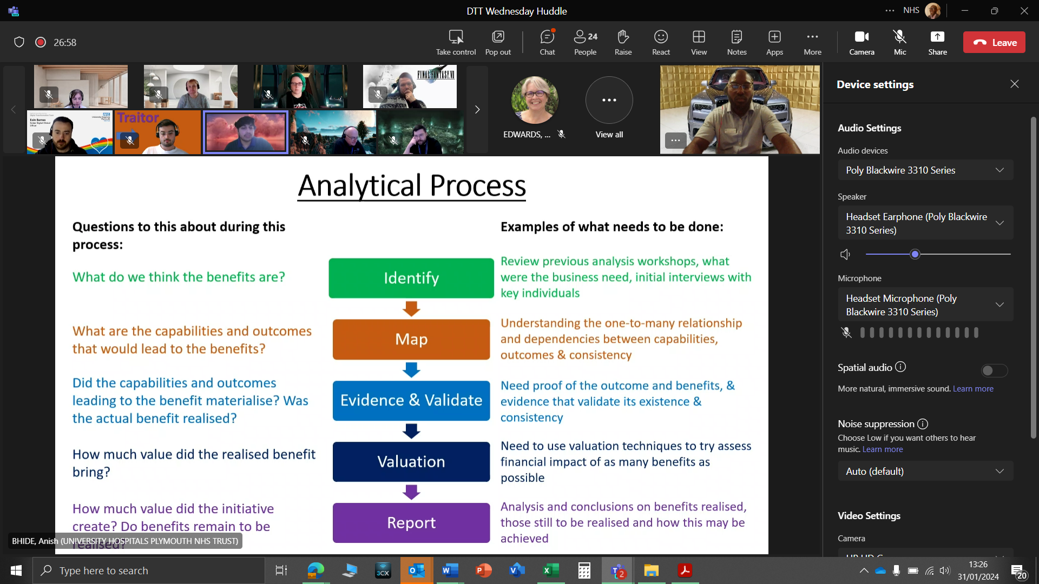

**Benefit Realisation Analysis for EPR Meeting 31st of January 202**

**BENEFIT OF OUTBOUND DATA SHARING**

* These will benefit the data stored in the NHS spine, such as the demographic database which is the **Patient Demographics Service (PDS)** and the **Summary Care Records (SCR).**
* Data interchange via NHS spine, such as **e-referrals(eRS**) and **electronic prescribing medication and administration (EPMA).**
* The data that flows to the NHS national databases (Clinical research, NHS business services, appointment databases and the Quality Outcome Framework (QOF), to mention a few.
* **For patient:**

1. enhances individuals' experiences by removing the need for them to constantly provide the same information to multiple health and care professionals, with the risks of forgetting anything vital.
2. increases productivity by eliminating the need for unnecessary, repetitive tests.
3. enhances safety and experience by making comprehensive and trustworthy allergy, medication, diagnostic, and social context information available in all health and care settings, such as A&E or when an ambulance is summoned.
4. provides individuals with access to shared healthcare records, which promotes citizens' engagement in their own treatment and adherence to medication and care plans.

* **For clinical:**

1. enhances health and care professionals' comprehension of a patient's condition, allowing clinicians to create a tailored treatment plan if necessary.
2. may reduce unnecessary hospital admissions or encourage more appropriate hospital admissions by providing health and care workers with more information about the individual when making clinical decisions.
3. Save time by eliminating the need to request information manually.

* **Service providers and commissioners:**

1. avoids redundant examinations or assessments, which saves money.
2. improves adult and child safety by exchanging alarms across numerous care settings.

**EPR BENEFITS FROM SHARING THE SAME SYSTEM:**

* **Overall Benefits: -**

1. The services will be covering a lot of miles across Devon.
2. Patients can visit more hospitals with ease which includes community hospitals or community or specialist care.
3. This will be no repeat of data to the different staff members.
4. The same system will help us to mitigate the rurality of our local area through enhanced clinical sharing and virtual clinical input for example a shared patient record means that somebody who lives in X area could have a medication review with a consultant in big city remotely saving them a long journey and improving their experience of our services.
5. Up-to-date information on a range of devices.
6. Faster pace to build the EPR system and lower cost.
7. Benefits for patients’ outcomes and safety will be achieved sooner with this sharing of knowledge and insights.
8. Cost saving (reduced payments to EPR supplier partners as well as opportunities for shared IT services.
9. No need to have different EPR knowledge for staff.

* **Overall challenges: -**

1. Effect will be increased when the system is to be shared across two or more organisations. Need to have a proper Executive.
2. Engagement of the organisation - Implementing an EPR system is a significant transformation initiative. Behavioural change is required for clinical transformation. Organisational involvement is required for clinical and operational leaders to take ownership of the change and allow employees to participate in shaping it. When two trusts are involved, everything becomes more complicated.
3. Information governance is putting in place the proper agreements to allow personnel to access and support a system that stores information on patients who have received care from both institutions. Data sharing and data processing agreements may be included. Patients may not expect their data to be shared across two trusts, thus steps must be taken to engage patients and communicate this.

* **lesson learned by the organisation.**

1. Determine additional expenses - there are significant savings, but there are some additional costs. When the new trust joins, the trust that is already on the EPR will have to re-test all its interfaces. Determine the costs and how they will be shared by the two trusts.
2. Manage the change control process - a decision must be made about when the new trust should be included in the process of managing what modifications are made to the EPR. The quickest method for a new trust to get the benefits of full participation may be to first focus on the business of going live and then participate in change control.
3. Begin data migration work with a third-party supplier as soon as possible - transferring patient data into a system that is already in use necessitates extreme caution. Begin as soon as possible. Also, do not do it in-house. Use a third-party source with the necessary tools and knowledge.

**SWOT ANALYSIS BENEFITS TO ELECTRONICS PATIENT RECORD(EPR)**

* **SWOT Analysis:**

**Electronic Patient Records (EPR)** would eliminate the long-standing tradition of using paper notes and switch to a new innovative digital system instead. This means the patient journey will be smoother by ensuring we deliver safe, personal and effective care. No matter the hospital the patient is admitted to the hospital would be able to access personal records quickly and securely. This will also eliminate repetition or duplication of information again and again. This will give all Clinicians and consultants access to everything they need, right at their fingertips which is from allergies to prescribing medications, it's all included in the new **Electronic Patient Records (EPR)** system. And the Nurses, Clinicians, consultants can spend more time with patients.

**WEAKNESS**

* Instalment and maintenance cost (Cost savings for large integrated institutions, not small rural practices)
* Reduce productivity during initial implementation phase (exacerbated by limited workforce in rural practice healthcare (PHC) units).
* Conflicting evidence in literature regarding improving quality of rural care.
* Synchronization of records (may be difficult to update records in a coordinated fashion at two locations where care is provided simultaneously.

**STRENGTH**

* Real-time, point-of-care data entry.
* Standardised classification of reasons for patient encounter(i.e. ICD-10 or ICPC-2)
* Effortless, remote management of clinical information.
* Improve efficiency(i.e. avoidance of diagnostic test duplication).
* Monitoring of morbidity local traits.

**OPPORTUNITIES**

* Data banking (Preservation and storage).
* Data synthesis (i.e., creating epidemiologic profiles of catchment area residents)
* Ability to synch up with mobile devices, allowing access to patient records from remote locations.
* Adjustment to regulatory compliance (i.e., NHS or insurance carrier new mandates).
* Networking (i.e., Practice based research network in primary care with access to Electronic Patient Records (EPR) system)

**THREATS**

* Adverse events may occur because of shortcomings of EPR system users, equipment or organisational/system capacity.

1. Human threats (i.e., careless employees or hackers)
2. Natural and environmental threats (i.e., flood, fire)
3. Technology failure (i.e., system crashing).

* Privacy and confidentiality concerns (i.e., unauthorised transmittal of patient record information)
* Health professional liability concerns (i.e., malpractice risk)

**CONCLUSION:** In conclusion, the introduction of Electronic Patient Records (EPR) across the trust would help the Trust and the regional partners in managing patient records so that patient care can be monitored and make sure that patient records/data can be stored in a more centralised place for easy access and management. This will help the Trust keep track on all the medications, treatments, surgical appointments, and community records in an easily accessible location for University Hospitals Plymouth NHS Trust (UHPTH).

**REFERENCES:**

* [Electronic Patient Records – How to procure an EPR software system (bestpracticegroup.com)](https://www.bestpracticegroup.com/electronic-patient-records-how-to-procure-an-epr-software-system/)
* [Electronic Patient Records - Where are we now? (elht.nhs.uk)](https://elht.nhs.uk/patients/EPR)
* [HTN Trends Series: EPR Trends in the UK - htn](https://htn.co.uk/2020/11/13/htn-trends-series-epr-trends-in-the-uk/#:~:text=There%20are%20two%20types%20of,schema%20and%20software%20development%20team.)
* [(2) The Benefits of Conducting a SWOT Analysis for Your Business | LinkedIn](https://www.linkedin.com/pulse/benefits-conducting-swot-analysis-your-business-gavin-bottrell/)
* [Advantages of SWOT Analysis (6 Benefits and 4 Limitations) (status.net)](https://status.net/articles/swot-analysis-process-benefits-limitations/)
* [5 Surprising Disadvantages of SWOT Analysis (pestleanalysis.com)](https://pestleanalysis.com/5-surprising-disadvantages-of-swot-analysis/)
* [SWOT analysis pros and cons: definition, use and tips | Indeed.com UK](https://uk.indeed.com/career-advice/career-development/swot-analysis-pros-and-cons)
* [What is PESTLE Analysis? An Important Business Analysis Tool](https://pestleanalysis.com/what-is-pestle-analysis/)
* [VMOST Analysis (Sondhi) explained - Toolshero](https://www.toolshero.com/strategy/vmost-analysis/)
* [MOST Analysis - What It Is And How To Use It | BusinessAnalystMentor.com](https://businessanalystmentor.com/most-analysis/)
* [Norfolk and Norwich University Hospitals NHS Foundation Trust » Electronic Patient Record (nuh.nhs.UK)](https://www.nnuh.nhs.uk/about-us/joint-working-across-norfolk-and-waveneys-acute-hospitals/electronic-patient-record/#:~:text=Some%20of%20the%20aims%20of,of%20lost%20or%20misplaced%20documents)
* [EPR - Benefits (sharepoint.com)](https://nhs.sharepoint.com/sites/RK9_UHPNTDigitalCareHub/SitePages/What-does-and-EPR-mean-to-me-.aspx)
* [Agile Software Development (learncybers.com)](https://learncybers.com/agile-software-development/)
* [Waterfall Methodology | What is Waterfall Methodology | Pipedrive](https://www.pipedrive.com/en/blog/waterfall-methodology)
* [Waterfall Project Management Methodology Explained - ThinkThyme](https://thinkthyme.com/project-management/waterfall-project-management-methodology#:~:text=The%20Basic%20Principles&text=The%20fundamental%20principle%20of%20waterfall,is%20reliant%20on%20the%20next.)